**AutoForesight : A Predictive Model for Streamlining Car Loan Repayment Planning**

# **Milestone 1: Project Initialization and Planning Phase**

The "Project Initialization and Planning Phase" marks the project's outset, defining goals, scope, and stakeholders. This crucial phase establishes project parameters, identifies key team members, allocates resources, and outlines a realistic timeline. It also involves risk assessment and mitigation planning. Successful initiation sets the foundation for a well-organized and efficiently executed machine learning project, ensuring clarity, alignment, and proactive measures for potential challenges.

# Activity 1: Define Problem Statement

Vehicle loan repayment prediction refers to the process of predicting whether or not a borrower will default on their vehicle loan. Default occurs when the borrower is unable or unwilling to repay the loan amount as agreed with the lender, leading to financial losses for the lender. The prediction is based on various factors related to the borrower and the loan itself. Some of the key factors that can affect loan repayment include:

Income: The borrower's income is a key factor in determining their ability to repay the loan. Higher income levels are associated with a lower risk of default.

Ref Template :[Click here](https://github.com/kaverikandikonda/CAR-LOAN-REPAYMENT/blob/main/2.Project%20initialization%20%26%20planning/Define%20Problem%20Statements%20.pdf)

# Activity 2: Project Proposal (Proposed Solution)

Machine learning algorithms can be used to predict loan repayment status based on these and other relevant factors. The goal is to build a predictive model that can accurately classify borrowers as either likely to default or not likely to default. This can help lenders make informed decisions about loan approvals, risk management, and loan pricing.

Ref Template:[Click here](https://github.com/kaverikandikonda/CAR-LOAN-REPAYMENT/blob/main/2.Project%20initialization%20%26%20planning/Project%20Proposal%20(Proposed%20Solution)%20.pdf)

# Activity 3: Initial Project Planning

The Autoforesight project utilizes AI and machine learning to predict the car loan repayment. It involves activities such as data collection and preparation, exploratory data analysis, model building, performance testing, and model deployment. These tasks are organized into sprints with specific functional requirements, user stories, story points, priorities, and team members assigned, ensuring efficient progress towards project goals.

Ref Template:[Cllick here](https://github.com/kaverikandikonda/CAR-LOAN-REPAYMENT/blob/main/2.Project%20initialization%20%26%20planning/Project%20Planning%20.pdf)

## Milestone 2: Data Collection and Preprocessing Phase

There are many popular open sources for collecting the data. Eg: kaggle.com, UCI repository, etc. In this project we have used .csv data. This data is downloaded from kaggle.com. Please refer to the link given below to download the dataset.

Link: [https://www.kaggle.com/datasets/meastanmay/nbfi-vehicle-loan-repaymentdataset?select=Train_Dataset.csv](https://www.kaggle.com/datasets/meastanmay/nbfi-vehicle-loan-repayment-dataset?select=Train_Dataset.csv)

As the dataset is downloaded. Let us read and understand the data properly with the help of some visualization techniques and some analyzing techniques.

Note: There are a number of techniques for understanding the data. But here we have used some of it. In an additional way, you can use multiple techniques.

The Machine Learning model cannot be trained on the imported data directly. The dataset might have randomness, we might have to clean the dataset and bring it in the right form. This activity involves the following steps:

* Handling Missing Values
* Handling Categorical Data
* Handling Imbalance Data

These are the general steps of pre-processing the data before using it for machine learning.

Depending on the condition of your dataset, you may or may not have to go through all these steps

# Activity 1: Data Collection Plan, Raw Data Sources Identified, Data Quality Report

The data collection plan for AutoForesight focuses on gathering high-quality information to build a predictive model for car loan repayment. Key parameters include borrower demographics, loan details, credit information, economic indicators, repayment history, and external financial factors. Data will be sourced from internal databases, credit bureaus, public economic data, financial institutions, and third-party providers.

The data quality report assesses accuracy, completeness, reliability, and biases. Accuracy will be verified through cross-checking and statistical methods, while completeness will ensure all necessary parameters are covered. Reliability will be maintained by regularly updating data from credible sources, and potential biases will be detected and mitigated to ensure fairness. Errors will be identified and corrected using robust data cleaning procedures. This thorough data quality assessment will form the foundation for developing a robust predictive model, with regular reviews to maintain high standards and adapt to new data requirements or financial landscape changes.

Ref Template:[Click here](https://github.com/kaverikandikonda/CAR-LOAN-REPAYMENT/blob/main/3.Data%20collection%20%26%20preprocessing/Raw%20Data%20Sources%20And%20Data%20Quality%20Report%20.pdf)

# Activity 2: Data Quality Report

The Data Quality Report for Prediction of car loan repayment project assesses the reliability and accuracy of the collected data, crucial for ensuring the effectiveness of AI algorithms in monitoring clients income and oother demographics. It examines factors like data completeness, consistency, accuracy, and potential biases. By identifying and addressing any issues, the report aims to enhance the trustworthiness and efficacy of the AI system.

Ref Template:[Click here](https://github.com/kaverikandikonda/CAR-LOAN-REPAYMENT/blob/main/3.Data%20collection%20%26%20preprocessing/Data%20Quality%20Report.pdf)

|  |
| --- |
|  |

# Activity 3: Data Exploration and Preprocessing

Data exploration and preprocessing for Prediction of car loan repayment project involves initial analysis and preparation of the collected data before feeding it into machine learning models. This includes tasks such as examining data distributions, identifying outliers, handling missing values, and potentially normalizing or scaling features. The goal is to ensure that the data is clean, relevant, and structured optimally for subsequent analysis, ultimately improving the performance and interpretability of the AI system in predicting the best outcome.

Ref Template:[Click here](https://github.com/kaverikandikonda/CAR-LOAN-REPAYMENT/blob/main/3.Data%20collection%20%26%20preprocessing/Data%20Exploration%20and%20Preprocessing%20.pdf)

## Milestone 3: Model Development Phase

In the model development phase of car loan repayment , machine learning algorithms are applied to the preprocessed data to build predictive models.This phase involves selecting appropriate algorithms, training them on the prepared data, and Decision Tree Classifier, Random forest , Naïve bayes, K-Nearest Neighbour model parameters for optimal performance. Additionally, techniques such as cross-validation and hyperparameter tuning are employed to ensure the robustness and generalizability of the models. The ultimate goal is to develop accurate and reliable car loan repayment prediction model.

# Activity 1: Feature Selection Report

The Feature Selection Report in Car loan repayment project evaluates the relevance and importance of different variables in predicting loan repayment outcomes. It identifies the most informative features while potentially reducing dimensionality and computational complexity. Techniques such as statistical tests, correlation analysis, and machine learning algorithms are utilized to rank and select the most influential features. The report aims to optimize model performance, interpretability, and computational efficiency by focusing on the most relevant factors for imporving the final prediction value.

Ref Template: [Click here](https://github.com/kaverikandikonda/CAR-LOAN-REPAYMENT/blob/main/4.Model%20development/Feature%20Selection%20Report%20.pdf)

# Activity 2: Model Selection Report

The Model Selection Report in Car loan repayment project compares the performance of various machine learning algorithms to determine the most suitable model for predicting car loan repayment outcomes. It assesses metrics such as accuracy, precision, recall, and F1 score across different models like Decision Tree , Random forest , Naïve Bayes, K-Nearest Neighbour, considering factors like computational complexity and interpretability. Techniques such as cross validation and hyperparameter tuning are employed to ensure robust evaluation.

Ref Template:[Click here](https://github.com/kaverikandikonda/CAR-LOAN-REPAYMENT/blob/main/4.Model%20development/Model%20Selection%20Report%20.pdf)

# Activity 3: Initial Model Training Code, Model Validation and Evaluation Report

The Initial Model Training Code person selected algorithms on the dataset, setting the foundation for predictive modelling. The subsequent Model Validation and Evaluation Report rigorously assesses model performance, person metrics like accuracy and precision to ensure reliability and effectiveness in predicting outcomes.

The initial model for Car loan repayment planning project, a Random Forest Classifier, was trained on features extracted from car loan dataset. Evaluation on a test set yielded an accuracy of 0.98, precision of 0.97, and F1score of 0.98. Further validation on diverse datasets is recommended for broader applicability.

Ref Template:[Click here](https://github.com/kaverikandikonda/CAR-LOAN-REPAYMENT/blob/main/4.Model%20development/Initial%20Model%20Training%20Code%2C%20Model%20Validation%20and%20Evaluation%20.pdf)

## Milestone 4: Model Optimization and Tuning Phase

In the Model Optimization and Tuning Phase of the Car loan repayent Planning project, techniques such as hyperparameter tuning and feature engineering are employed to enhance the performance of the predictive models. This involves fine-tuning model parameters, optimizing algorithms, and selecting the most relevant features to improve accuracy, precision, recall, and overall model performance. The goal is to refine the AI system for more accurate and reliable prediction of car loan repayment outcomes, thereby facilitating better decision-making.

# Activity 1: Hyperparameter Tuning Documentation

The Hyperparameter Tuning Documentation in the Car loan repayment planning project outlines the process of optimizing model performance by adjusting hyperparameters. Techniques such as grid search or random search are typically used to explore different combinations of hyperparameters and identify the optimal settings. The documentation includes details on the hyperparameters being tuned, the search strategy employed, and the evaluation metrics used to assess performance. The aim is to fine-tune the model for improved accuracy, precision, recall, and overall effectiveness in predicting car loan repayment outcomes.

Ref Template:[Click here](https://github.com/kaverikandikonda/CAR-LOAN-REPAYMENT/blob/main/5.Model%20optimization%26%20tunning/Model%20Optimization%20and%20Tuning%20Phase%20.pdf)

# Activity 2: Performance Metrics Comparison Report

The Performance Metrics Comparison Report in the Car loan repayment planning project compares various evaluation metrics across different models or approaches. Metrics such as accuracy, precision, recall, and F1score are typically assessed to gauge the performance of each model in predicting Car loan repayment planning outcomes. The report summarizes the findings, highlighting the strengths and weaknesses of each approach and providing insights into the most effective methods for decisionmaking.

Ref Template:[Click here](https://github.com/kaverikandikonda/CAR-LOAN-REPAYMENT/blob/main/5.Model%20optimization%26%20tunning/Model%20Optimization%20and%20Tuning%20Phase%20.pdf)

# Activity 3: Final Model Selection Justification

The Final Model Selection Justification in the Car loan repayment planning project is based on a comprehensive evaluation of model performance metrics such as accuracy, precision, recall, and F1score. The selected model demonstrates the highest predictive capability and generalizability across diverse datasets. Its effectiveness in accurately predicting car loan repayment value makes it the most suitable choice for deployment , offering valuable support for Car loan repayment system.

Ref Template:[Click here](https://github.com/kaverikandikonda/CAR-LOAN-REPAYMENT/blob/main/5.Model%20optimization%26%20tunning/Model%20Optimization%20and%20Tuning%20Phase%20.pdf)

**Milestone 5: Results:**

Activity 1: Output Screenshots:

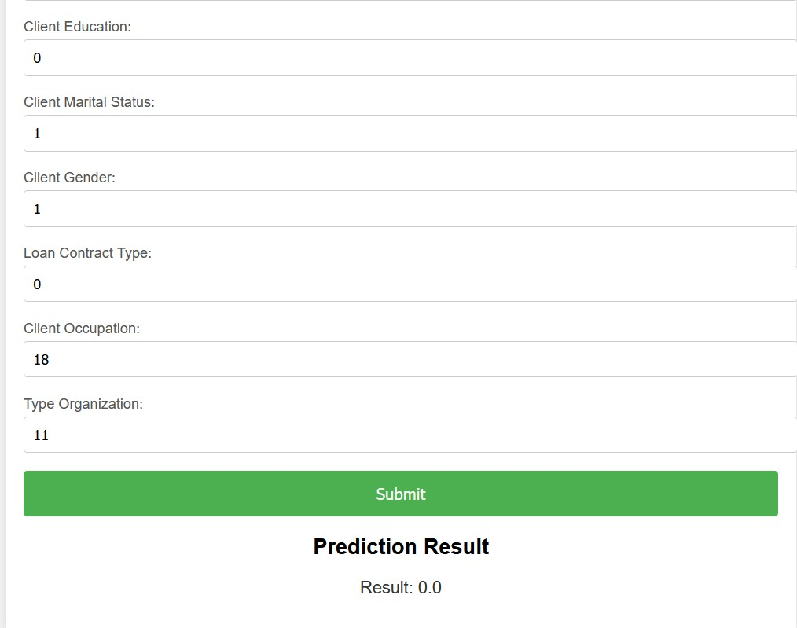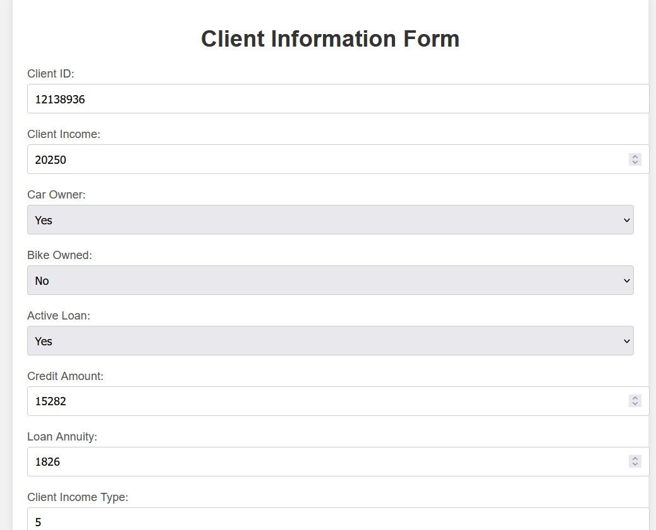

Activity 2: Advantages & Disadvantages:

**Advantages:**

1. **Improved Accuracy in Risk Assessment:** Machine learning algorithms can analyze vast amounts of data, including borrower profiles, economic indicators, and loan repayment histories, to accurately predict the likelihood of default or timely repayment. This enables lenders to assess risks more effectively and make informed decisions, potentially reducing defaults and improving overall loan portfolio performance.
2. **Personalized Loan Terms:** ML models can identify patterns in borrower behavior and financial profiles, allowing lenders to offer personalized loan terms such as interest rates, repayment schedules, and loan amounts. This personalization enhances customer satisfaction and can lead to increased loan approvals and lower borrower default rates.
3. **Operational Efficiency:** Automation of loan approval processes through ML can significantly reduce the time and resources required for manual underwriting and decision-making. By streamlining operations, lenders can handle a larger volume of loan applications efficiently while maintaining consistency and compliance with regulatory requirements.

**Disadvantages:**

1. **Data Privacy and Security Concerns:** ML models rely heavily on data, including sensitive borrower information. Handling and storing this data raise concerns about privacy breaches and unauthorized access, necessitating robust security measures and compliance with data protection regulations (e.g., GDPR, CCPA).
2. **Algorithmic Bias and Fairness Issues:** ML models may inadvertently incorporate biases present in historical data, leading to unfair outcomes such as discrimination in loan approvals based on factors like race, gender, or socioeconomic status. Addressing algorithmic bias requires careful data preprocessing, model evaluation, and ongoing monitoring to ensure fairness.
3. **Complexity and Interpretability:** ML models, particularly complex ones like deep learning algorithms, can be difficult to interpret and understand how they arrive at specific predictions or decisions. Lack of transparency may pose challenges in explaining outcomes to stakeholders, regulators, or borrowers, potentially impacting trust and acceptance of automated decision-making systems.

Activity 3: Conclusion & Future Scope:

**Conclusion:**

Implementing machine learning in "AutoForesight" offers promising benefits like enhanced risk assessment and operational efficiency in car loan repayment planning. However, challenges such as data privacy concerns and algorithmic bias must be carefully addressed to ensure fairness and compliance. Overall, leveraging ML can significantly optimize lending processes and improve borrower satisfaction.

Future Scopes:

1. Integration of real-time economic indicators for dynamic risk assessment.
2. Implementation of Explainable AI (XAI) techniques to enhance transparency in lending decisions.

# **Milestone 6: Project Files Submission and Documentation**

For project file submission in Github, Kindly click the link and refer to [Click here](https://github.com/kaverikandikonda/CAR-LOAN-REPAYMENT)

For the documentation, Kindly refer to the [Click Here](https://github.com/kaverikandikonda/CAR-LOAN-REPAYMENT/blob/main/7.Documentation%20and%20demonstration/Project%20Documentation%20(1).pdf)